sCOMP 3123 – Full Stack Development – Lab 1
- JavaScript Refresher Exercises

Exercise 1:
Write a JavaScript program to capitalize the first letter of each word of a given string.

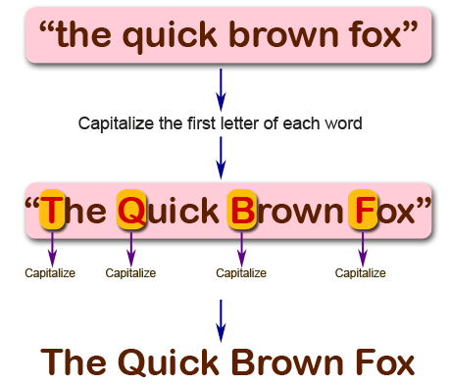

Exercise 2:
Write a JavaScript program to find the largest of three given integers.
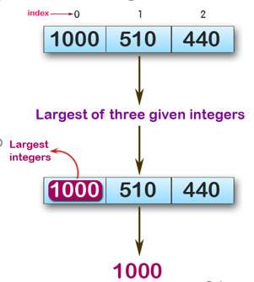
console.log(max (1,0,1));
console.log(max (0,-10,-20));
console.log(max (1000,510,440));

Sample Output:
1
0
1000

Exercise 3:
Write a JavaScript program to move last three character to the start of a given string. The string length must be greater or equal to three.

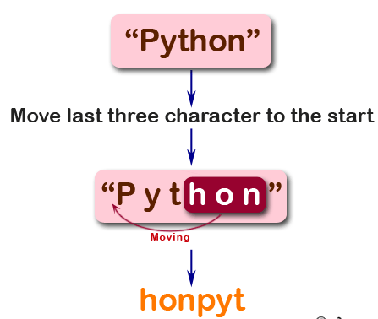
console.log(right("Python"));
console.log(right("JavaScript"));
console.log(right("Hi"));
Sample Output:
honPyt
iptJavaScr
Hi

Exercise 4:
Write a JavaScript program to find the types of a given angle.
Types of angles:
• Acute angle: An angle between 0 and 90 degrees.
• Right angle: An 90 degree angle.
• Obtuse angle: An angle between 90 and 180 degrees.
• Straight angle: A 180 degree angle.
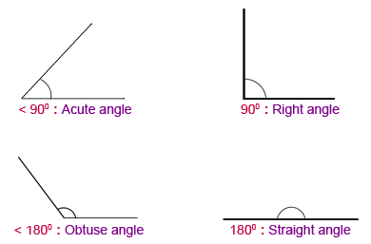
console.log(angle_Type(47))
console.log(angle_Type(90))
console.log(angle_Type(145))
console.log(angle_Type(180))
Sample Output:
Acute angle
Right angle
Obtuse angle
Straight angle

Exercise 5:
Write a JavaScript program to find the maximum possible sum of some of its k consecutive numbers (numbers that follow each other in order.) of a given array of positive integers.
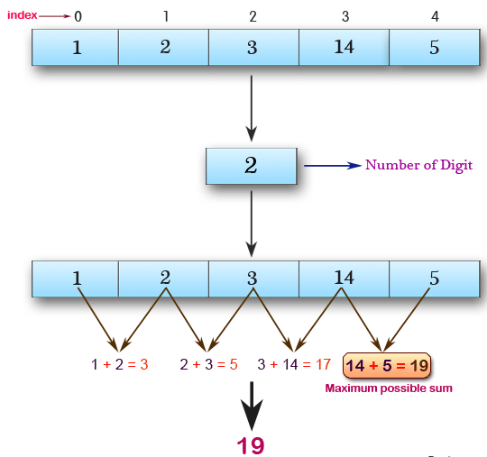

console.log(array_max_sum([1, 2, 3, 14, 5], 2))
console.log(array_max_sum([2, 3, 5, 1, 6], 3))
console.log(array_max_sum([9, 3, 5, 1, 7], 2))

Sample Output:
19
12
12

